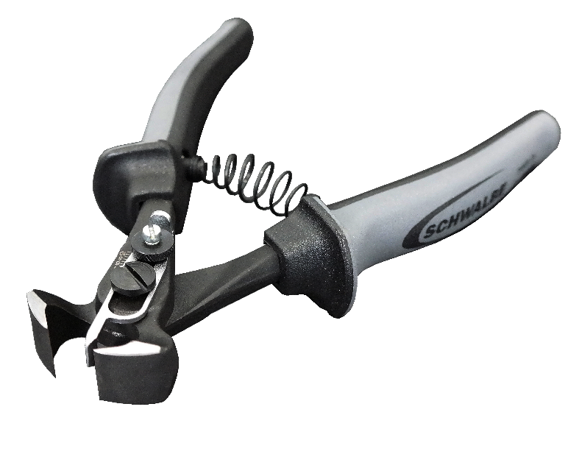

**For tire-tread fine tuning: Schwalbe's new tread cutter.**

The first tread cutter specifically for MTB tires

Sharp cuts for fine tuning: Schwalbe presented the first tread cutter for MTB tires at the opening round of the MTB World Cup in Lourdes, France, April 7th to 10th. The tongs, with their exact tread-height adjustment function, allow precise shortening of the tire lugs.

"Although we offer a suitable tread for every type of terrain, sometimes unpredictable trail conditions require a unique tread to find the perfect balance of rolling and grip", says Michael Kull from Schwalbe Marketing and Race Support. "With the tread cutter, riders can adapt the tire tread even more perfectly to the respective situation." For example, the sturdy center lugs of our mud-terrain tire, Dirty Dan, can be shortened for easier rolling. Or, as with Hans Dampf, the transition lugs in the shoulder area can be trimmed, giving more free space, and making the tread more aggressive. Lugs that have been worn "round" can have a straight edge again. Kull: "This is the first tread cutter developed specifically for MTB tires. With it, you can cut the lugs off with a smooth edge and – thanks to the cutting-height adjustment – to your exact required height."

The tread cutter will be available at the end of April from specialty bike retailers (€26.90).

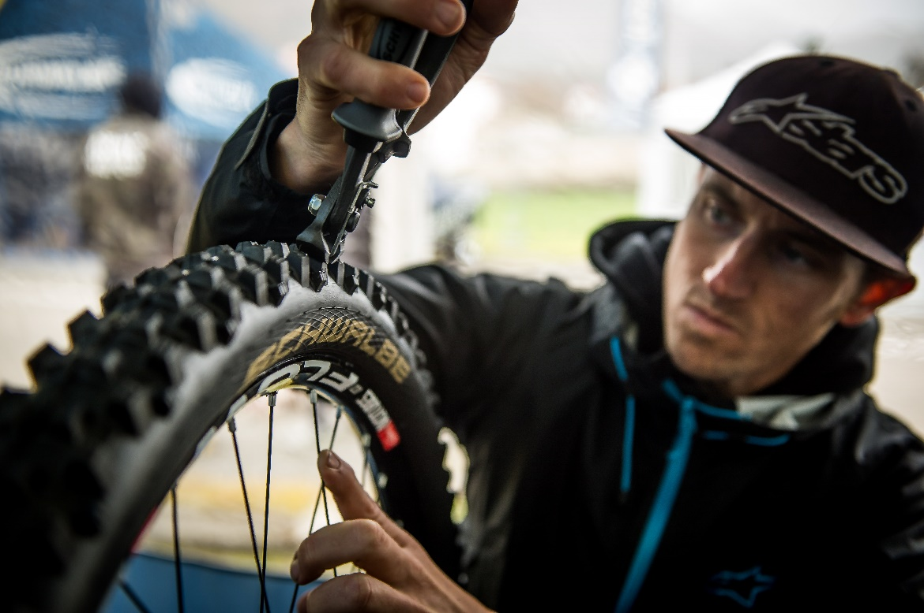

**Schwalbe's new tread cutter in use at the UCI World Cup in Lourdes.**

**This press release with photos and graphic illustrations**

**can be downloaded at:** [**http://presse.schwalbe.de**](http://presse.schwalbe.de/)

SCHWALBE | Ralf Bohle GmbH

Doris Klytta

Otto-Hahn-Straße 1

51580 Reichshof-Wehnrath

Telephone: +49 2265 109-57

Fax: +49 2265 7022

[www.schwalbe.com](http://www.schwalbe.com/)

[d.klytta@schwalbe.com](mailto:d.klytta@schwalbe.com)